1. LINQ SequenceEqual Method in C#

The LINQ SequenceEqual Method in C# checks whether two sequences are equal. If two sequences are equal, it returns true; otherwise, it returns false. Two sequences are considered to be equal when both the sequences have the same number of elements, as well as the same values, and should be present in the same order. There are two overloaded versions available for this SequenceEqual Method in LINQ. They are as follows.

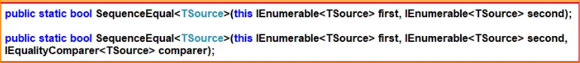

As you can see, the second overloaded version takes an extra IEqualityComparer parameter. So, whenever you don’t want the default comparer to be used by the LINQ SequenceEqual Method, you need to use this overloaded version to use your own comparer.

Key points to note about SequenceEqual:

It compares the elements in both sequences one by one, from the beginning to the end.

If the two sequences’ lengths are different or any element in the first sequence does not match the corresponding element in the second sequence, the result will be false.

The sequences must contain elements of the same type for the comparison to work correctly.

The SequenceEqual method is useful when you need to verify if two sequences are identical in terms of their elements and order. It can be used for equality checks in various scenarios, such as verifying data integrity, comparing results, or checking for matching sequences in unit tests.

1. Example to Understand LINQ SequenceEqual Method in C#:

Let us see an example to understand the LINQ SequenceEqual Method in C# using both method and query syntax. In the following example, we created two sequences to store the cities. As you can see, both collections contain the same number of elements. Further, if you notice, all the elements are in the same order in both collections. So here, the sequences are equal, and the SequenceEqual method will return true. There is no such operator called SequenceEqual available in LINQ to write the query syntax, so, in that case, we can go with method syntax.

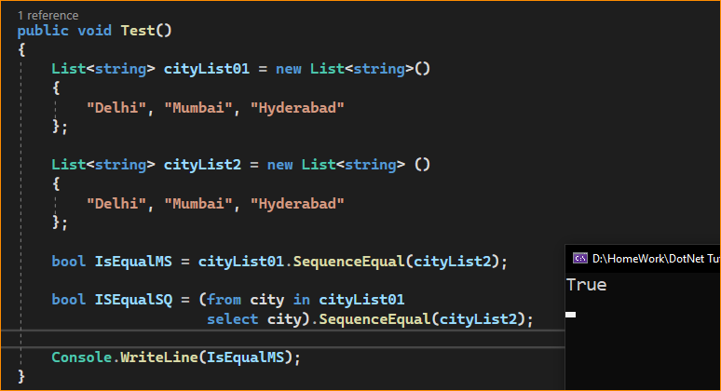

Now, modify the example as follows. Here, we have the same cities but with different cases. The default compare, used by the SequencesEqual method, is case-sensitive. So, the below example returns false as the values are case-sensitive.

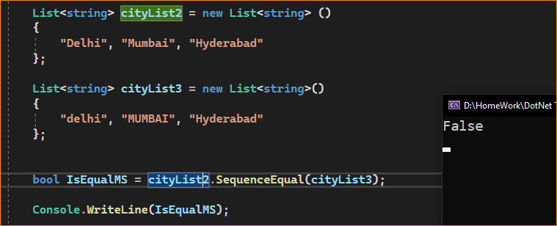

If you want the comparison to be case-insensitive, you need to use the other overloaded version of the SequenceEqual() method, which takes **IEqualityComparer** as a parameter. So, modify the Example as follows to use the second overloaded version of the SequenceEqual() method, which takes IEqualityComparer. Here, you can see we are passing **StringComparer.OrdinalIgnoreCase** is the second parameter to the SequenceEqual() method. The StringComparer class implements the IEqualityComparer interface.

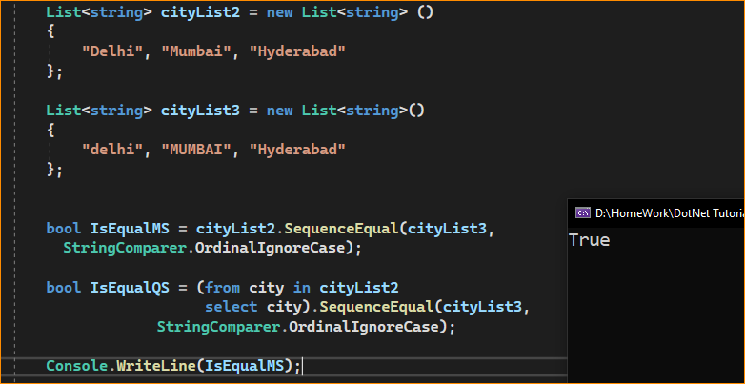

Note: If you go to the definition of StringComparer class, you will see that this class implements the IEqualityComparer interface.

1. What Happens if the Elements are not present in the same order?

If the Elements are not present in the same order in both sequences, then the SequenceEqual method will return False. In the following example, the SequenceEqual method returns false. This is because the elements are not in the same order in both sequences.

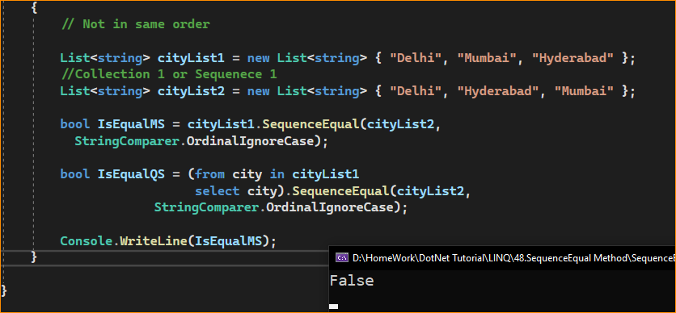

1. How Can We Solve the Above Problem?

If sequences contain the same data but in a different order, and you want the SequenceEqual method to return true, then, first, you need to sort the data either in ascending or descending order in both the sequences and then only apply the LINQ SequenceEqual method which is shown in the below example.

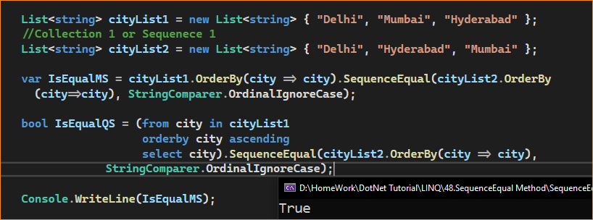

1. Working with Complex Type using LINQ SequenceEqual Method:

Let us understand how to work with the LINQ SequenceEqual with Complex Data type in C#. To understand this, we will work with the following Student class. So, create a class file named Student.cs and copy and paste the following code. Here, you can see we have created the Student class with two properties, i.e., ID and Name. Then we have also created two methods, i.e., GetStudents1 and GetStudents2. Further, if you notice, these two methods will return the same data.

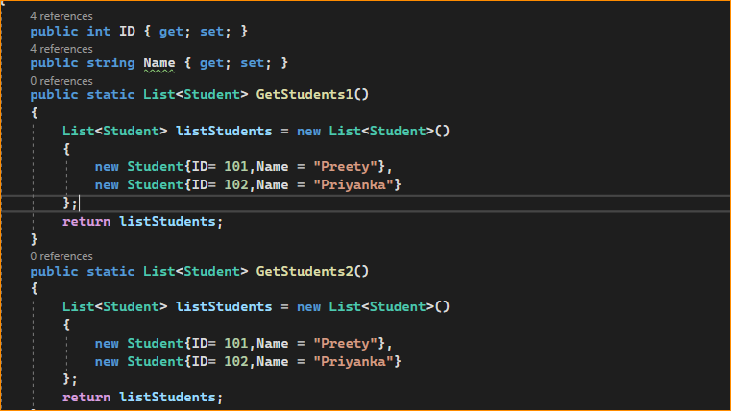

Now, what we will do is we will check whether both the sequences that are returned by the GetStudents1 and GetStudents2 methods are the same or not using the LINQ SequenceEqual method. So, modify the Main method of the Program class as shown below.

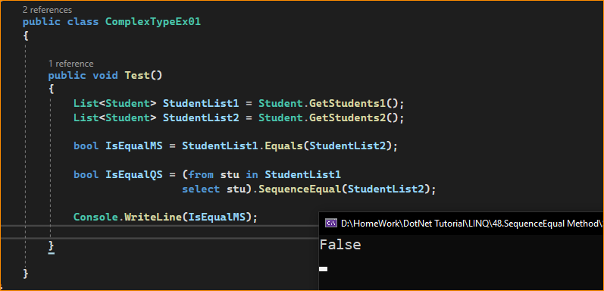

Even though both sequences contain the same data, we are getting the result as False. This is because when working with complex types, the default comparer used by the SequenceEqual method will only check if the object references are equal or not. It is not checking the object values; rather, it is checking the object references, and references are different in this case, and hence it returns False.

* How to Solve the Above Problem?

Solving the Above Problem means ensuring the SequenceEqual method goes for value equality rather than reference equality, i.e., we need to tell the SequenceEqual method to check the individual object values rather than object reference addresses. There are many ways we can solve the above problem. Some of them are as follows.

* Creating Custom Comparer. We need to use the other overloaded version of the SequenceEqual method to pass a custom class that implements the IEqualityComparer interface.
* We must Project the properties into a new anonymous type, which already overrides Equals() and GetHashCode() methods.
* We must override the Equals() and GetHashCode() methods in the Student class.
* By Implementing IEquatable<T> interface

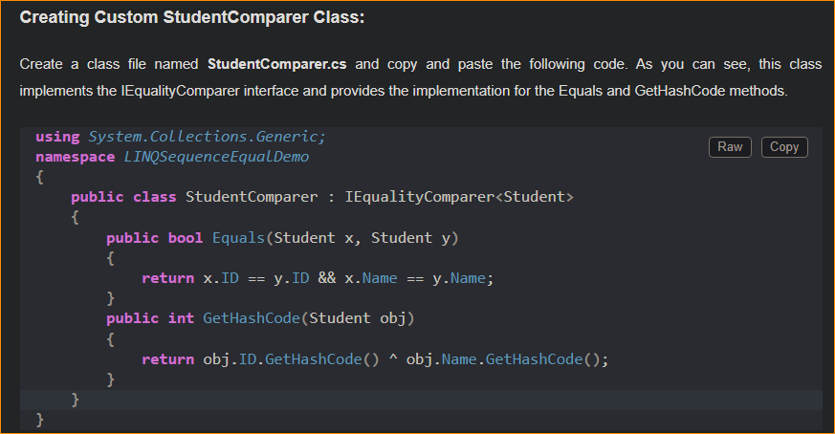

Next, modify the Main method of the Program class as follows. Now, we need to create an instance of the StudentComparer class, and then we need to pass that instance to the SequenceEqual method, shown in the code below. With these changes, the compare, which we pass to the SequenceEqual method, will be used to check the equality, and this will use the individual object values, not the object reference.

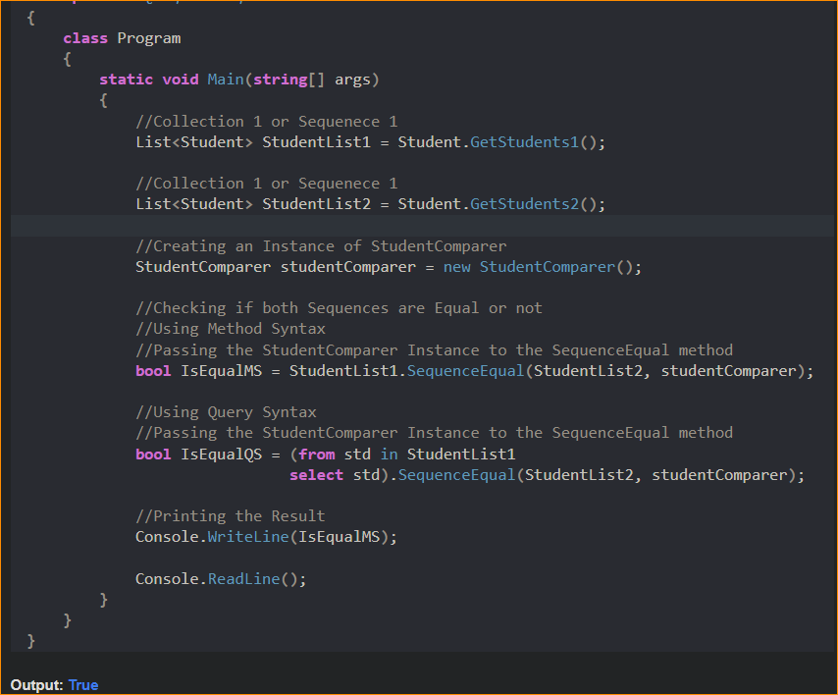

1. Using Anonymous Type with LINQ SequenceEqual Method:

In this approach, we must select all the individual properties to an anonymous type. The following program does exactly the same thing. In the below example, we are projecting the data into an anonymous type.

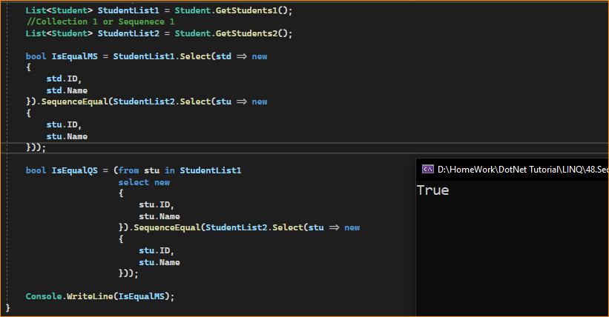

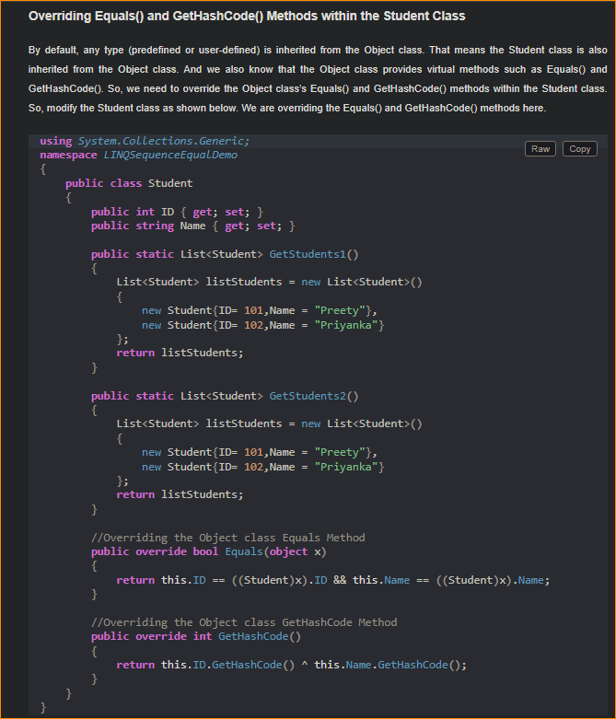

With the above changes in place, now modify the Main method of the Program class as shown below. Now, we need to use the overloaded version of the LINQ SequenceEqual method, which does not take any parameter.

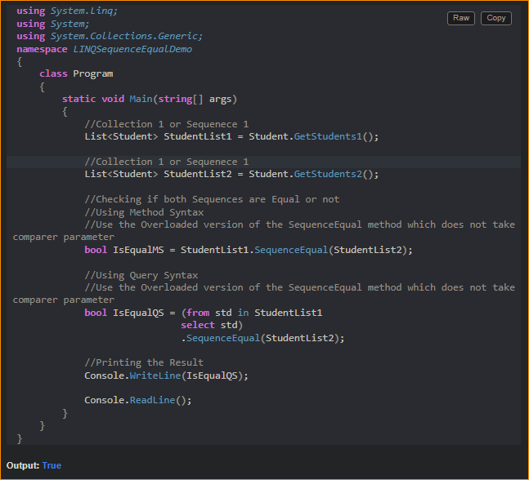

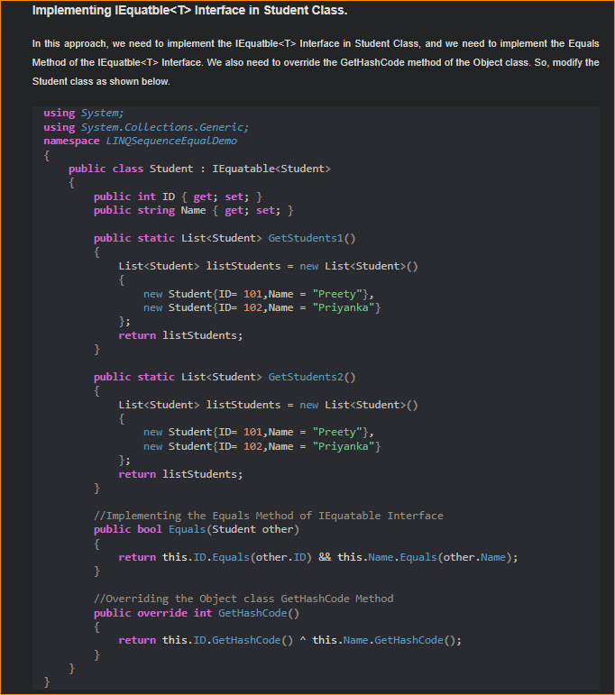

As you can see, here we have done two things. First, we implement the Equals method of the IEquatable interface, and then we override the GetHashCode method of the Object class. With the above changes in place, now modify the Main Method of the Program class as shown below. Again, here, we need to use the overloaded version of the LINQ SequenceEqual method, which does not take any parameter.

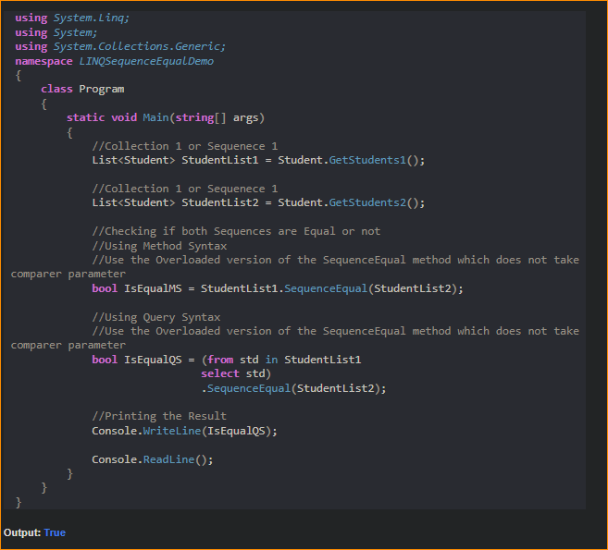

1. Important Points to Consider

* Element Comparer: SequenceEqual uses the default equality comparer for the type of elements in the sequence by default. If you need to compare elements based on a specific property or use custom logic, you may need to provide an IEqualityComparer<T> to the SequenceEqual method.
* Order Matters: SequenceEqual considers the order of elements. If two sequences contain the same elements but in a different order, SequenceEqual will return false.
* Performance: SequenceEqual can be more efficient for large sequences than manually comparing elements because it will stop as soon as it finds two unequal elements.
* Deferred Execution: Like many LINQ methods, SequenceEqual uses deferred execution.

1. When to Use LINQ SequenceEqual Method in C#?

You should use the LINQ SequenceEqual method in C# when comparing two sequences (collections or arrays) to determine if they contain elements in the same order. Here are common scenarios where you should consider using the SequenceEqual method:

* Data Validation: When you want to validate that two collections or arrays have identical elements and order, especially when working with data that should match or have consistency.
* Unit Testing: In unit testing, you can use SequenceEqual to verify whether the actual output of a method or operation matches the expected output in terms of elements and their order.
* Data Integrity Checks: When dealing with data from different sources or databases, you can use SequenceEqual to ensure that data retrieved from one source matches the data retrieved from another source.
* Sorting and Ordering: If you have sorting or ordering logic in your code, SequenceEqual can be used to verify that the sorting or ordering process did not change the sequence’s content.
* Comparing User Input: In applications that involve user input, you can use SequenceEqual to compare user-provided data with expected data to check if it matches, ensuring data consistency.
* Testing Algorithm Outputs: When working with algorithms or custom logic that generates sequences, you can use SequenceEqual to verify that the output of your algorithm matches the expected output.
* Database Queries: When you’re querying a database and retrieving data as sequences, you can use SequenceEqual to compare the retrieved data against an expected dataset.
* API Responses: When interacting with APIs, SequenceEqual can help you validate that the data received from the API matches what you expected, allowing you to ensure data integrity.
* Caching and Caching Validation: In caching scenarios, you can compare data retrieved from a cache with data retrieved from a source to check if the cached data is still valid.
* Monitoring and Data Consistency: In real-time monitoring or data synchronization applications, SequenceEqual can be used to verify that data remains consistent between different systems or at different points in time.

The SequenceEqual method is valuable when you must compare two sequences to ensure they contain the same elements in order. It is particularly useful for data validation, unit testing, data integrity checks, and various scenarios where you need to verify the consistency and correctness of sequences.